Attendance: Please have your child at school by 7:45 every morning. Make school a priority!


Book Reports: Students will be expected to read a book and complete a book report each nine-weeks.

Communication: Please let me know if there is a concern or problem.

Dismissal: School ends at 2:45.
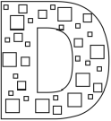
Emergency Numbers:
Please make sure the front office has your correct phone numbers.

Field Trip: Third grade field trips always need parent volunteers.
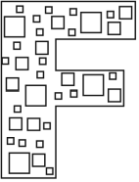

Grading Scale:
A = 90 - 100
B = 80 – 89
C = 75 – 79
D = 74 – 70
F = 69 - 50


Homework: Your child will have homework on Mon. through Thurs. night


Internet: Your child will use the internet for extra reading and math.



Journals: Your child will write in journals throughout the year.
Keep: Students must be responsible for keeping their things organized.


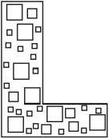
Lunch: Feel free to enjoy lunch with your child.

Management: I use a behavior sheet that must be signed by parents every day.


Notes: All absences must have a note sent to school.

Open Classroom: Please feel free to come read to my class.

PTA: Please join our Parent/Teacher Association and come to the monthly meetings.
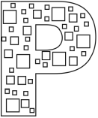
Questions: Please do not hesitate to contact me at school at 841-0701 if you have questions.


Reading: Your child will be studying reading strategies to prepare them to be successful on the TAKS test.


Science: We will focus on the solar system, plants, magnets and electricity in science.

Tardies: All students must be at school by 7:45.
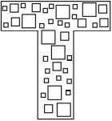
Unkind Behavior:
Unkind behavior is not tolerated. Students must respect one another.

Volunteers: Our class welcomes volunteers to help in our class room.


Winners: Our classroom environment is designed so that your child can come to school to learn and feel safe.



I am excited to work with your child.

Please be sure your child gets plenty of zzzzz’s each night.

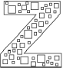



Dawson Elementary
3001 South 1st Street
Austin, Texas 78704
(512) 841-0701
Welcome to my class!
Ms. Gibbs
Room 302

A Parent Resource Pamphlet
2007-2008



